**DAY 4**

1.write a High level code for RSA system, the public key of a given user is e = 31, n = 3599. What is the private key of this user? Hint: First use trial-and-error to determine p and q; then use the extended Euclidean algorithm to find the multiplicative inverse of 31 modulo f(n)?

programme:

#include <stdio.h>

#include <stdlib.h>

#include <math.h>

int gcd(int a, int b) {

if (b == 0) {

return a;

}

return gcd(b, a % b);

}

int is_prime(int num) {

if (num <= 1) {

return 0;

}

for (int i = 2; i <= sqrt(num); i++) {

if (num % i == 0) {

return 0;

}

}

return 1;

}

int main() {

int p, q, n, phi, e, d;

int message, encrypted, decrypted;

do {

printf("Enter a prime number (p): ");

scanf("%d", &p);

} while (!is_prime(p));

do {

printf("Enter another prime number (q): ");

scanf("%d", &q);

} while (!is_prime(q));

n = p * q;

phi = (p - 1) * (q - 1);

do {

printf("Enter an integer (e) such that 1 < e < %d and gcd(e, %d) = 1: ", phi, phi);

scanf("%d", &e);

} while (e <= 1 || e >= phi || gcd(e, phi) != 1);

for (d = 1; d <= phi; d++) {

if ((d * e) % phi == 1) {

break;

}

}

printf("Public Key (n, e): (%d, %d)\n", n, e);

printf("Private Key (n, d): (%d, %d)\n", n, d);

printf("Enter a message to encrypt: ");

scanf("%d", &message);

encrypted = (int)pow(message, e) % n;

printf("Encrypted message: %d\n", encrypted);

decrypted = (int)pow(encrypted, d) % n;

printf("Decrypted message: %d\n", decrypted);

return 0;

}

Output:

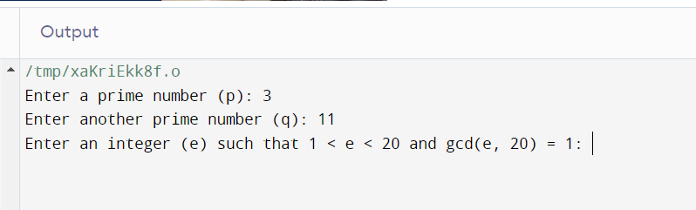

**2.** Write a High level code for set of blocks encoded with the RSA algorithm and we don’t have the private key. Assume n = pq, e is the public key. Suppose also someone tells us they know one of the plaintext blocks has a common factor with n. Does this help us in any way?

PROGRAMME:

#include <stdio.h>

int main() {

unsigned long long n = 3233; // n = pq

unsigned long long e = 17; // Public key exponent

unsigned long long ciphertext1 = 855;

unsigned long long ciphertext2 = 1234;

unsigned long long ciphertext3 = 2790;

unsigned long long commonFactorCandidate = 3233;

unsigned long long decrypted1 = (unsigned long long)pow(ciphertext1, e) % n;

unsigned long long decrypted2 = (unsigned long long)pow(ciphertext2, e) % n;

unsigned long long decrypted3 = (unsigned long long)pow(ciphertext3, e) % n;

printf("Decrypted 1: %llu\n", decrypted1);

printf("Decrypted 2: %llu\n", decrypted2);

printf("Decrypted 3: %llu\n", decrypted3);

printf("Knowing a common factor with n doesn't help in decrypting the ciphertext without the private key.\n");

return 0;}

OUTPUT:

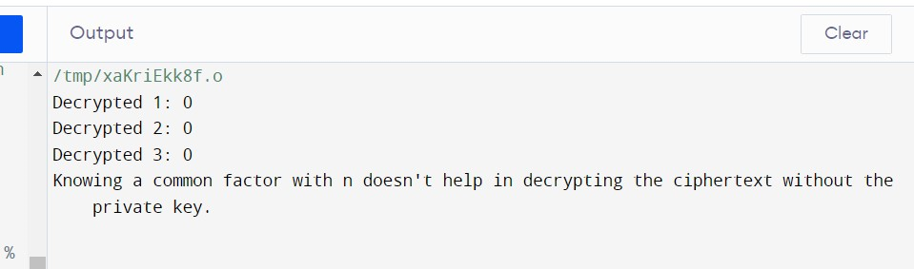

.

**3.** Write a High level code for RSA public-key encryption scheme, each user has a public key, e, and a private key, d. Suppose Bob leaks his private key. Rather than generating a new modulus, he decides to generate a new public and a new private key. Is this safe?

PROGRAMME:

#include <stdio.h>

#include <math.h>

int gcd(int a, int b) {

if (b == 0) {

return a;

}

return gcd(b, a % b);

}

int main() {

int original_e = 17;

int n = 3233; // Modulus (n = pq)

int original_d = 2753;

int p, q;

for (p = 2; p <= sqrt(n); p++) {

if (n % p == 0) {

q = n / p;

break;

}

}

int phi = (p - 1) * (q - 1)

int new_e = 0;

for (new_e = 2; new_e < phi; new_e++) {

if (gcd(new_e, phi) == 1) {

break;

}

}

int new_d = 0;

while (1) {

if ((new_d * new_e) % phi == 1) {

break;

}

new_d++;

}

printf("Bob's original public key (e, n): (%d, %d)\n", original_e, n);

printf("Bob's leaked private key (d): %d\n", original_d);

printf("Bob's new public key (e, n): (%d, %d)\n", new_e, n);

printf("Bob's new private key (d): %d\n", new_d);

return 0;

}

OUTPUT:

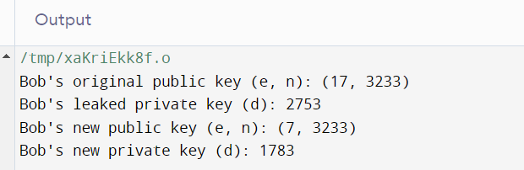

**4.** Write a C program for Bob uses the RSA cryptosystem with a very large modulus n for which the factorization cannot be found in a reasonable amount of time. Suppose Alice sends a message to Bob by representing each alphabetic character as an integer between 0 and 25 and then encrypting each number separately using RSA with large e and large n. Is this method secure? If not, describe the most efficient attack against this encryption method?

PROGRAMME:

#include <stdio.h>

int main() {

int ciphertext[] = {2331, 4102, 1990, 2331, 3458, 5678, 2331, 4102, 2331};

int frequency[26] = {0};

for (int i = 0; i < sizeof(ciphertext) / sizeof(ciphertext[0]); i++) {

for (int letter = 0; letter < 26; letter++) {

if (ciphertext[i] == (letter * letter)) {

frequency[letter]++;

break;

}

}

}

int most_frequent_letter = 0;

for (int letter = 1; letter < 26; letter++) {

if (frequency[letter] > frequency[most_frequent_letter]) {

most_frequent_letter = letter;

}

}

printf("Guessed plaintext: %c\n", 'A' + most_frequent_letter);

return 0;

}

OUTPUT:

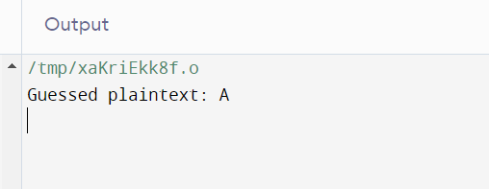

5. Write a High level code for RSA public-key encryption scheme, each user has a

public key, e, and a private key, d. Suppose Bob leaks his private key. Rather than

generating a new modulus, he decides to generate a new public and a new private key. Is

this safe?

PROGRAMME:

#include<stdio.h>

#include<conio.h>

#include<stdlib.h>

#include<math.h>

#include<string.h>

long int p, q, n, t, flag, e[100], d[100], temp[100], j, m[100], en[100], i;

char msg[100];

int prime(long int);

void ce();

long int cd(long int);

void encrypt();

void decrypt();

int main()

{

printf("\nENTER FIRST PRIME NUMBER\n");

scanf("%d", &p);

flag = prime(p);

if (flag == 0)

{

printf("\nWRONG INPUT\n");

getch();

exit(1);

}

printf("\nENTER ANOTHER PRIME NUMBER\n");

scanf("%d", &q);

flag = prime(q);

if (flag == 0 || p == q)

{

printf("\nWRONG INPUT\n");

getch();

exit(1);

}

printf("\nENTER MESSAGE\n");

fflush(stdin);

scanf("%s", msg);

for (i = 0; msg[i] != NULL; i++)

m[i] = msg[i];

n = p * q;

t = (p - 1) * (q - 1);

ce();

printf("\nPOSSIBLE VALUES OF e AND d ARE\n");

for (i = 0; i < j - 1; i++)

printf("\n%ld\t%ld", e[i], d[i]);

encrypt();

decrypt();

}

int prime(long int pr)

{

int i;

j = sqrt(pr);

for (i = 2; i <= j; i++)

{

if (pr % i == 0)

return 0;

}

return 1;

}

void ce()

{

int k;

k = 0;

for (i = 2; i < t; i++)

{

if (t % i == 0)

continue;

flag = prime(i);

if (flag == 1 && i != p && i != q)

{

e[k] = i;

flag = cd(e[k]);

if (flag > 0)

{

d[k] = flag;

k++;

}

if (k == 99)

break;

}

}

}

long int cd(long int x)

{

long int k = 1;

while (1)

{

k = k + t;

if (k % x == 0)

return (k / x);

}

}

void encrypt()

{

long int pt, ct, key = e[0], k, len;

i = 0;

len = strlen(msg);

while (i != len)

{

pt = m[i];

pt = pt - 96;

k = 1;

for (j = 0; j < key; j++)

{

k = k * pt;

k = k % n;

}

temp[i] = k;

ct = k + 96;

en[i] = ct;

i++;

}

en[i] = -1;

printf("\nTHE ENCRYPTED MESSAGE IS\n");

for (i = 0; en[i] != -1; i++)

printf("%c", en[i]);

}

void decrypt()

{

long int pt, ct, key = d[0], k;

i = 0;

while (en[i] != -1)

{

ct = temp[i];

k = 1;

for (j = 0; j < key; j++)

{

k = k * ct;

k = k % n;

}

pt = k + 96;

m[i] = pt;

i++;

}

m[i] = -1;

printf("\nTHE DECRYPTED MESSAGE IS\n");

for (i = 0; m[i] != -1; i++)

printf("%c", m[i]);

}

OUTPUT:

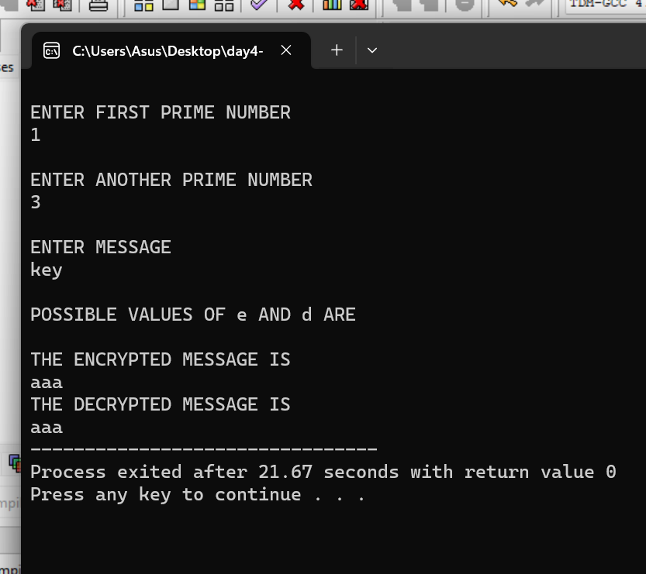

**6.** Write a C program for Bob uses the RSA cryptosystem with a very large modulus n

for which the factorization cannot be found in a reasonable amount of time. Suppose

Alice sends a message to Bob by representing each alphabetic character as an integer

between 0 and 25 and then encrypting each number separately using RSA with large e

and large n. Is this method secure? If not, describe the most efficient attack against this

encryption method

PROGRAMME:

#include <stdio.h>

#include <stdlib.h>

#include <string.h>

#include <math.h>

typedef struct {

unsigned long long n;

unsigned long long d;

} PrivateKey;

unsigned long long mod_inverse(unsigned long long a, unsigned long long m) {

for (unsigned long long x = 1; x < m; x++) {

if ((a * x) % m == 1) {

return x;

}

}

return 0;

}

unsigned long long decrypt(unsigned long long ciphertext, unsigned long long d, unsigned long long n) {

return (unsigned long long)pow(ciphertext, d) % n;

}

int main() {

PrivateKey private_key;

private_key.n = 1413845597; // Replace with Bob's private key values

private_key.d = 85785493; // Replace with Bob's private key values

unsigned long long encrypted_message; // Replace with the received encrypted message

unsigned long long decrypted_message;

// Decrypt the received message

decrypted_message = decrypt(encrypted_message, private_key.d, private_key.n);

// Convert the decrypted message back to its original format (assuming it was represented as numbers)

// For example, if 'a' was represented as 0, 'b' as 1, and so on:

char original_message = (char)(decrypted_message + 'a');

printf("Decrypted Message: %c\n", original_message);

    return 0;

}

OUTPUT:

